**A picture containing clipart

Description generated with very high confidence**

Creating a Manifest

DevOps Certification Training

[**support@intellipaat.com**](mailto:support@intellipaat.com)

**+91-7022374614**

**US: 1-800-216-8930(Toll Free)**

**CREATING A MANIFEST**

**Steps for Puppet Master**

**Step 1:** Change the directory to **/etc/puppet/code/environments/production/manifests**

$ cd /etc/puppet/code/environments/production/manifests

$ sudo nano site.pp

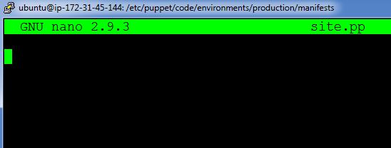

**Step 2:** Enter the following text:

node default{

package{'nginx':

ensure => installed,

}

file{'/tmp/status.txt':

content=> "nginx installed",

mode=> '0644',

}

}

**Installing Puppet Agent**

**Step 2:**  Run the following commands for installing Puppet Agent

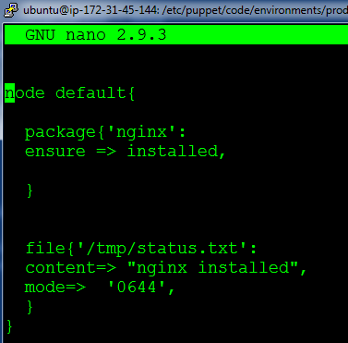

**On Puppet Agent**

**Step 1:** Execute the following command:

$ sudo puppet agent --test

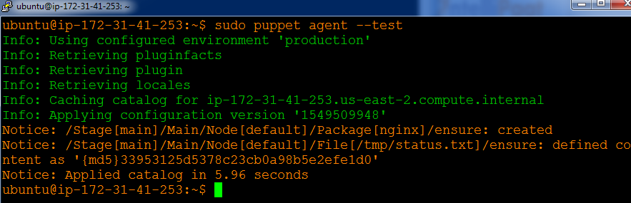

**Step 2:** Verify the installation and file by going to the browser, with agent’s ip address. Also check /tmp/status.txt

